Diesel knit sneakers with intarsia pattern
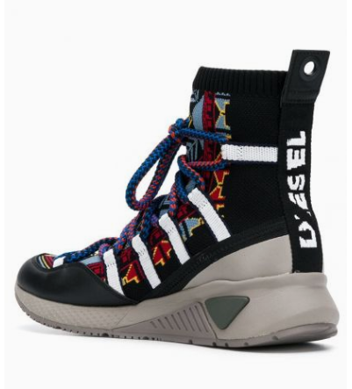
$236

Multicolored intarsia Diesel knit sneakers with round toe, rubber flat sole, lace-up fastening at the front, back tongue and ankle heel.

